**ASR**

**From:** Phoen, Eugene   
**Sent:** Monday, 05 February, 2018 9:23 AM  
**To:** Chan, Pei-Fong  
**Cc:** Lee, Kar Mei; Lee, Kar Mun  
**Subject:** Amend outbound handling report

Hi Pei Fong,

Can you please help amend the Outbound Handling Report?

As the KPI measurement has changed slightly, need to add the “Planned GI Date” into the report, ideally add it as the 2nd column

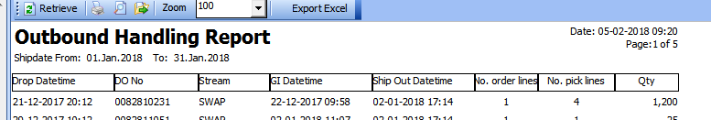

Best Regards,

Eugene Phoen

Assistant Manager

Contract Logistics/SCM, Operations